Project Group 6: Elijah Abuel, Susan Quiros, Harika Peddiraju, & Mohan Panga

Conclusion LA Compensation and Housing

Through our analysis, we can conclude that:

Out of the sixteen different job class titles chosen, only two of them are aligned with the housing percentage growth of 7% with respect to the base payment. However, we get a different scenario when comparing the housing growth with respect to the total payments. Here a total of nine job class titles show align with the same tendency and this effect can be explained by the overtime payments and bonuses that are added to the base pay through the fiscal year. 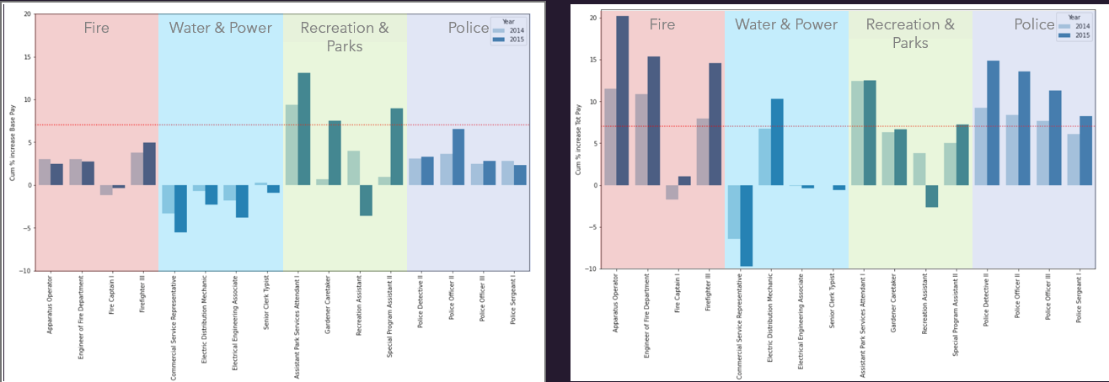

Recreation & Parks exhibits three job class titles meeting/exceeding the housing price growth of 7% according to their base pay.

The LA Fire Department, Water & Power, Recreation & Parks, and the Police Department exhibit multiple job class titles exceeding the 7% housing price rate.

Essentially this means that, should all things remain the same, if their initial income in 2013 is sufficient to afford housing of that year, any job class title can afford housing in future years.